South Sudan

Boya/Larim tribe (Kapoeta region)
The Boya (also spelled Buya: called Larim and Langorim by the Didinga people) are a Surmic ethnic group numbering between 20 – 25,000 people living in Budi County, part of the Greater Kapoeta region of the South Sudanese state (Eastern Equatoria). The language of the Boya is the Surmic Narim language, related to that of the Didinga, Tenet and Murie in South Sudan. The people mostly live in the south and west Boya Hills, in the Mt. Kosodek and Mt. Lobuli areas. The main town is Kimatong, at the foot of the hills. They are agro-pastoralist, cultivating sorghum, maize and beans, but mainly involved in livestock hearding, hunting game and fishing.

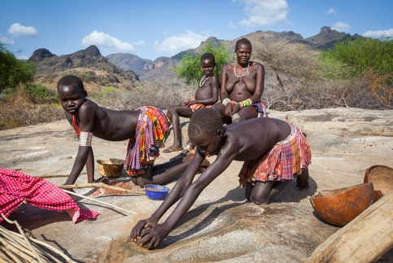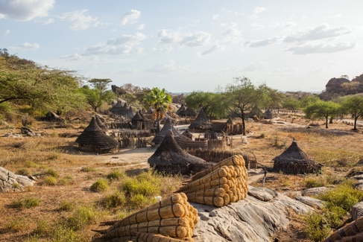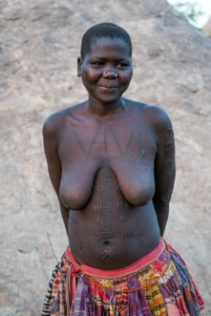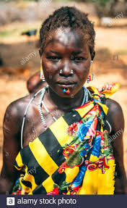
Boya Hill Tribe

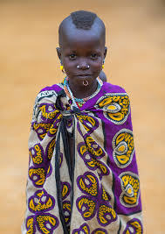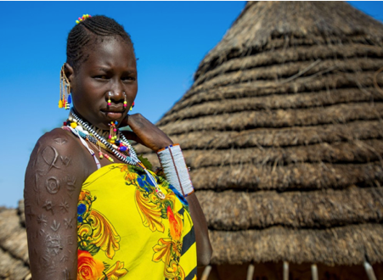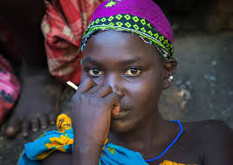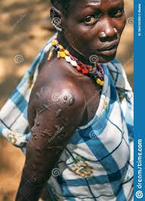
Larim People

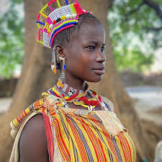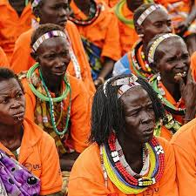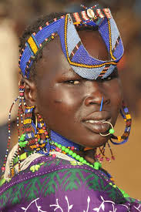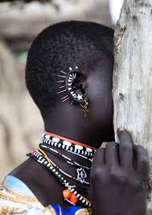

Kapoeta region

Toposa People (Kapoeta region) Jiye Territory
Historically, the Toposa people (part of the Nilotic group) were part of the "Karamojong cluster" of present-day Uganda, leaving the area in the late 16th century, eventually settling in eastern part of the State of Eastern Equatoria (part of the historic Equatoria region). Traditionally they lived by herding cattle, sheep and goats, low-level warfare (usually cattle raids, against their neighbours), and in the past were involved in the ivory trade. The Toposa have always competed for water and pasturage with their neighbours, and have always engaged in cattle rustling.
The Toposa have a population of about 207,000 in South Sudan, representing its 6th or 7th largest ethnic group.^{[15]} There is no clear political organization among the Toposa, although respect is paid to elders, chiefs and wise men. Most decisions about the clan or community are made in meetings attended only by the men, traditionally held in the dark hours before the dawn. The Toposa believe in a supreme being and in ancestral spirits.
During the civil wars, they at times supported the SPLA, and at other times supported the army of Sudan.

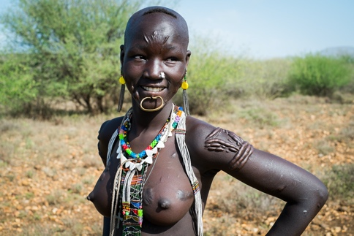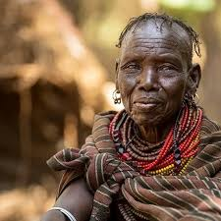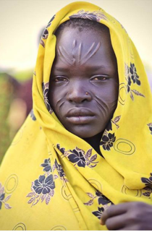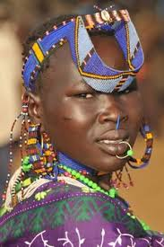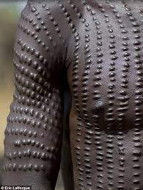

Toposa People

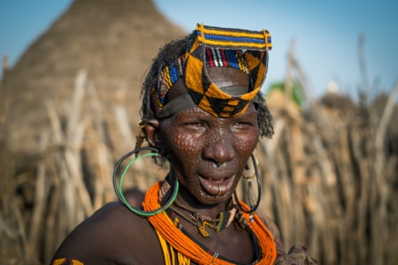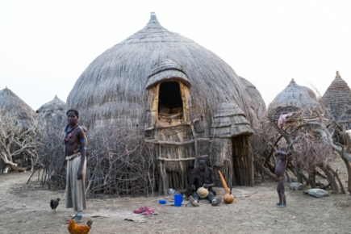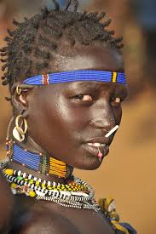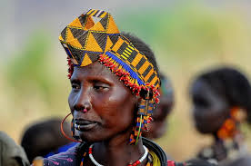

Jiye People

Dinka People
The Dinka people (part of the Nilotic group) have no centralized political authority, but are instead organized by several independent but interlaced clans. The Dinka people are the largest group in South Sudan, representing 35.8% of the population in 2013^{[21]} (depending on the source, between 1 and 4 million people) and live primarily in Anglo-Egyptian Sudan's historic province of Bahr el Ghazal. Today, the region consists of the South Sudan states Northern Bahr el Ghazal, Lakes, and Warrap, with significant presence in the historic province of Greater Upper Nile's states of Jonglei, Upper Nile, and Unity.
Traditionally, the Dinkas believe in one God (Nhialic) who speaks through spirits (jok) that take temporary possession of individuals. British missionaries in the late 19th century introduced Christianity, which now predominates.
The region was one of the scenes of fighting in the First Sudanese Civil War. In 1983 a member of the Dinka group, John Garang de Mabior founded the Sudan People’s Liberation Army, which led to the Second Sudanese Civil War. The SPLA later became the army of South Sudan.

The Dinka people (Dinka: Jiɛ̈ɛ̈ŋ) are a Niloticethnic group native to South Sudan with a sizable diaspora population abroad. The Dinka mostly live along the Nile, from Bor to Renk, in the region of Bahr el Ghazal, Upper Nile (two out of three Provinces which were formerly located in southern Sudan, and the Abyei Area of the Ngok Dinka in South Sudan.
The Dinka mainly practice traditional agriculture and pastoralism, relying on cattle husbandry as a matter of cultural pride, not as a source of commercial profit or meat, but as a means to perform cultural demonstrations, rituals, marriage dowries and milk feedings for people of all ages.^{[citation needed]} The Dinka cultivate food crops and cash crops. The food crops are grains, mainly sorghum and millet. The cash crops include groundnuts, sesame and gum-Arabic.^{[citation needed]}Cattle are confined to riversides, the Sudd and grass areas during the dry season, but are taken to high grounds in order to avoid floods and water during the rainy season.^{[citation needed]}
They number around 4.5 million people according to the 2008 Sudan census, constituting about 18% of the population^{[1]} of the entire country, and the largest ethnic tribe in South Sudan. Dinka, or as they refer to themselves, Muonyjang (singular) and jieng (plural), make up one of the branches of the River Lake Nilotes(mainly sedentary agripastoral peoples of the Nile Valleyand African Great Lakes region who speak Nilotic languages, including the Nuer and Luo)

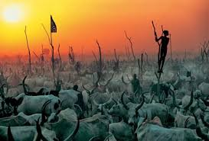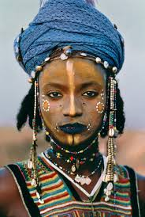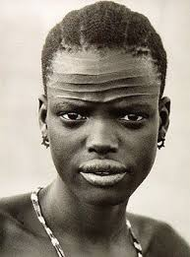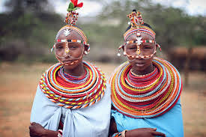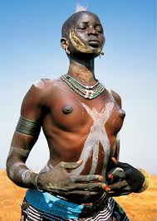

Dinka People

Mandari People
he Mandari are a small ethnic group of South Sudanand part of the Karo people one of the Nilotic peoples.
The group is composed of cattle-herders and agriculturalists and are part of Karo people which also includes Bari, Pojulu, Kakwa, Kuku and Nyangwara. Kutuk na Mundari is also the name of their language, which is in similar to Kutuk na Kuku, Kutuk na Kakwa, Kutuk na Pojulu, Kutuk na Bari, and Kutuk na Nyangwara.
The traditional Mundari tribal lands are located roughly 75 kilometres north of Juba, the capital of South Sudan, and are centred on the town of Terekeka in the state of Central Equatoria. They are bordered to the north by the Bor Dinka at Maliththoor, Anuet, and to the south by the Bari of Juba 12 km at the Ku'da River. Their lands are bounded on the east by the White Nile and extend west to Laka Ma'di in Western Equatoria state, an area roughly 100 by 75 kilometres in size.
The land, like much of South Sudan, is predominantly flat and marked by occasional isolated large hills. The low-lying land contains many rivers and lakes and is prone to flooding during the rainy season. The soil is predominantly clay-based, causing drainage and water retention problems, and provides a very fertile basis in support of cattle grazing.

The Mundari, like other Nilotic tribes, are very cattle-oriented: cattle serves as food, a form of currency and a mark of status. Marriages are arranged by the prospective groom offering cattle to the bride's family and husbands may take as many wives as they can support. The Mundari engage in perennial cattle raiding wars with the BorDinka during the dry season.
The Mundari also cultivate sorghum and catch fish using nets and spears.
In common with other Nilotic tribes in Sudan, the Mundari practice ritual scarification as a rite of passage into adulthood for young men. The typical Mundari scar pattern consists of two sets of three parallel lines, each on either side of the forehead, extending in a downward slope and unconnected in the middle.

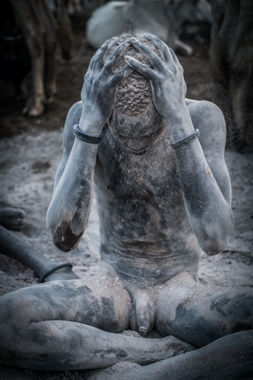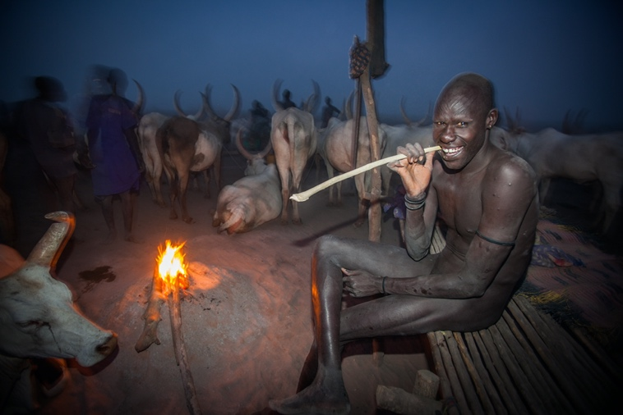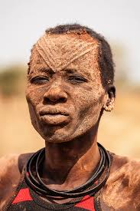

Ethnic group maps

